Css preprocessors

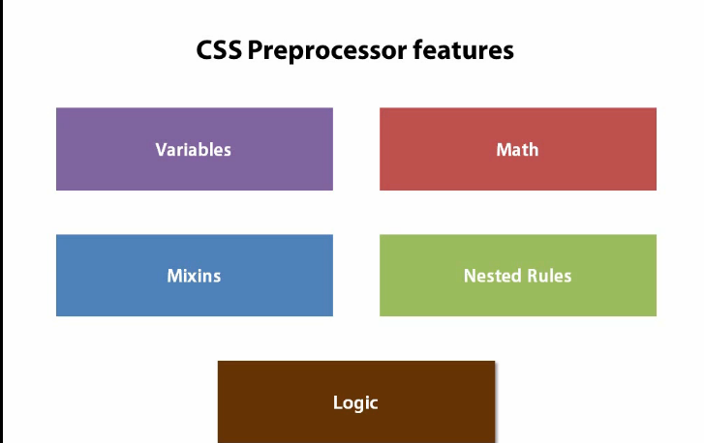

css reset and normalize

Scope and closures in js

Hoisting in js

Visual and NonVisual Testing, : testing our application in multiple browsers

We can have many tools for visual and non visual testing. Taking ‘Karma’ for non visual testing

Window object is the global object. All the global scope variables which are declared in any of the js files are associated to the window object.

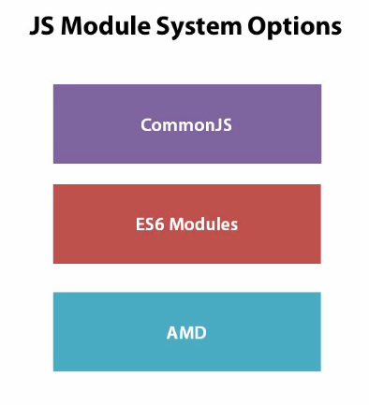

**Underscore functions:**

_.each

_.map

_.filter

_.indexOf

_.bind

_.once

_.keys

_.values

_.isFunction

_.isArray

_.isObject

_.escape

CSS to top of the file

Js files to bottom